***INDUSTRIAL TRAINING REPORT ON***

**DATA ANALYSIS**



**Submitted by: KESHAV**

**Bachelor of Engineering (Information Technology)**

UNIVERSITY INSTITUTE OF ENGINEERING AND TECHNOLOGY

PUNJAB UNIVERSITY CHANDIGARH

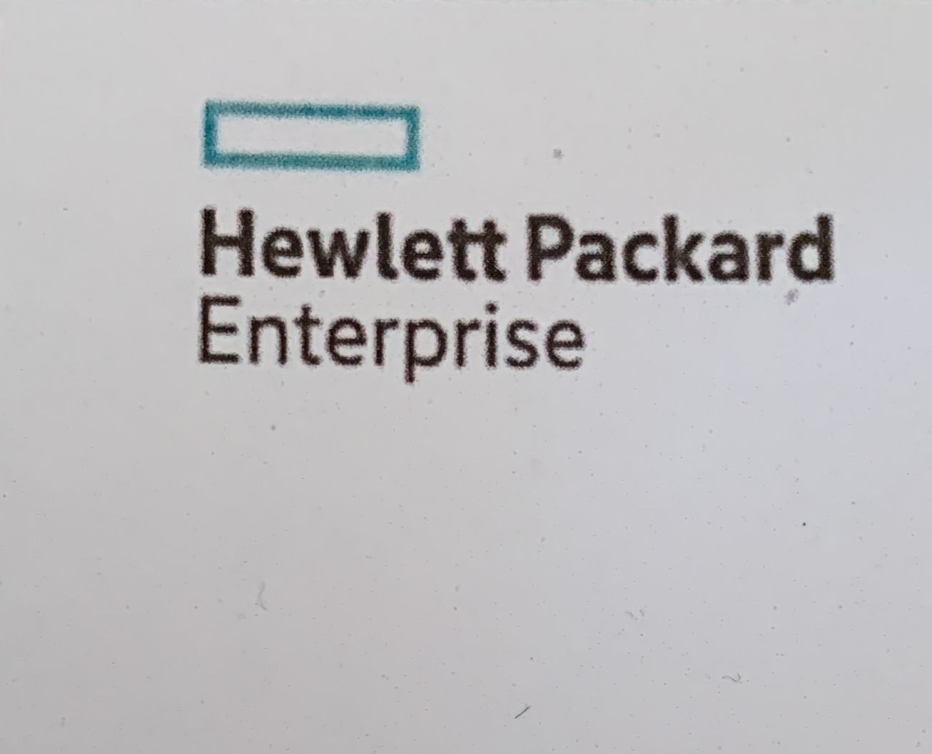

**Submitted To**

**Mr. Malaya Jena**

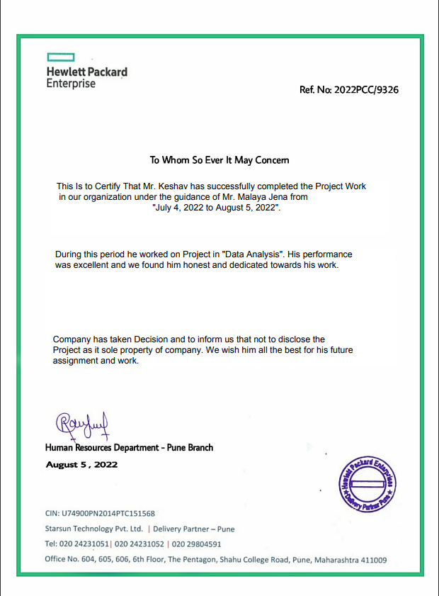

**ACKNOWLEDGEMENT**

We are very thankful to **“Mr. MALAYA JENA”** to give us the opportunity to build this project. We are also very thankful to our teacher guide because without his guidance it would not be possible to build this project.

Last but not the least we would like to thank the U.I.E.T for Giving us to this opportunity to do this project.

KESHAV

ROLL NO- UE208051

**CONTENTS:-**

1. **Introduction to Data Analysis.**
2. **Intro to Tableau and its uses.**
3. **Details about dataset.**
4. **Details of the analysis made from each sheet.**
5. **Reason for preferring the graph selected to represent the data in that sheet.**
6. **A screenshot of the dashboard and the link to your public dashboard.**
7. **CONCLUSION**
8. **REFERENCE**
9. **INTRODUCTION**

* Data analysis is the practice of working with data to get useful information, which can then be used to make informative decisions.
* A simple example of Data analysis is whenever we take any decision in our day-to-day life is by thinking about what happened last time or what will happen by choosing that particular decision.
* Various tools used are: MS Excel, Python, Tableau,MySQL.

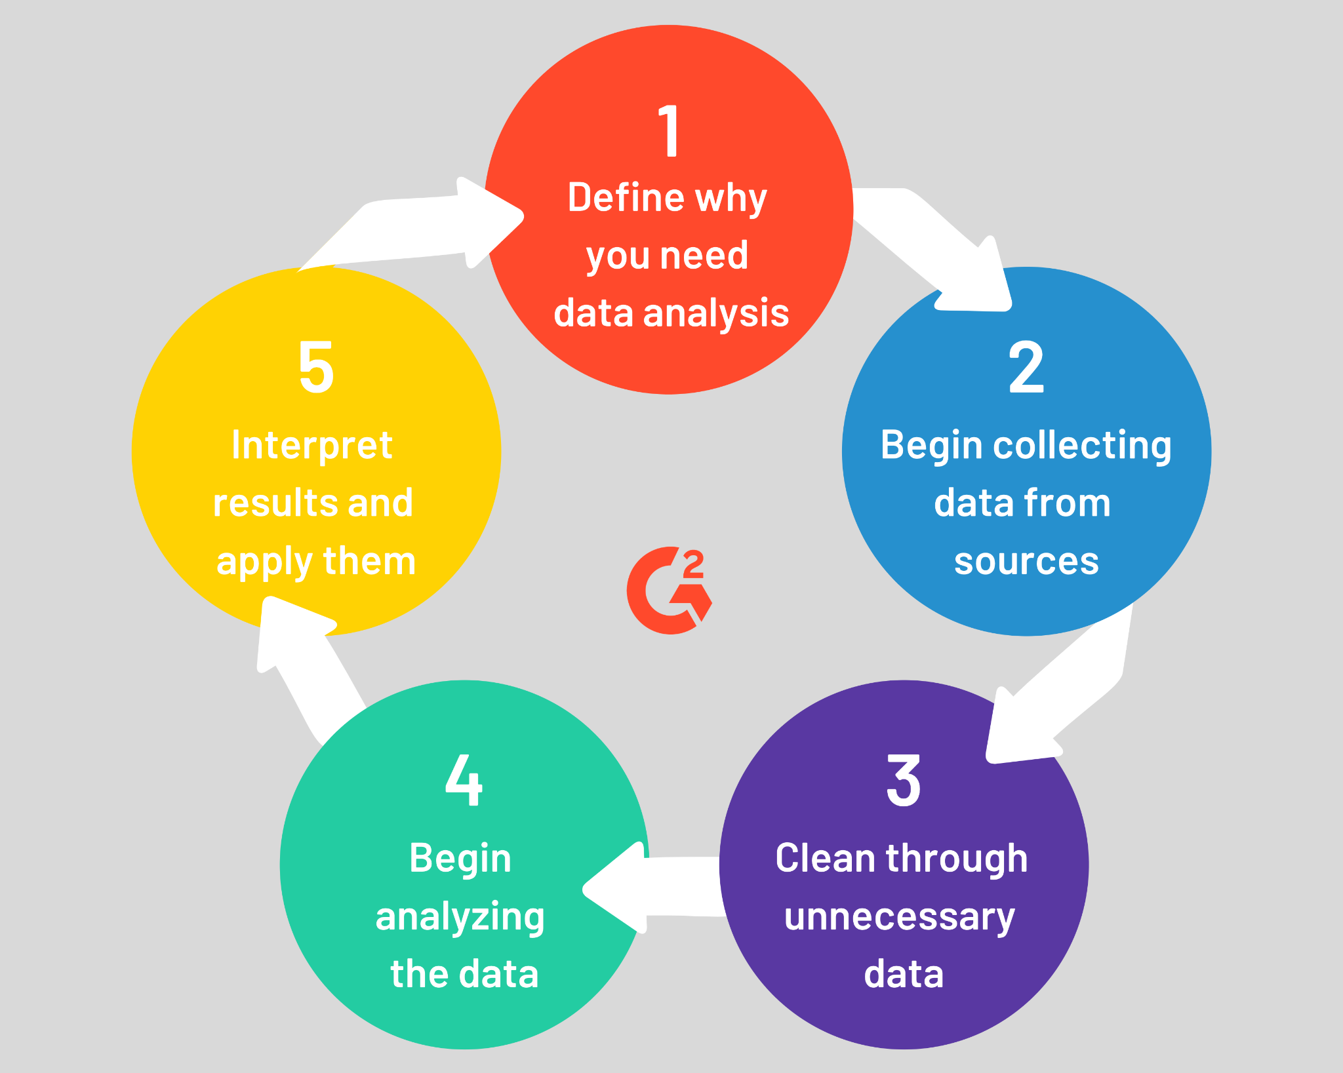

USES :-

Data analysis can **help companies better understand their customers, evaluate their ad campaigns, personalize content, create content strategies and develop products**. Ultimately, businesses can use data analytics to boost business performance and improve their bottom line.

**Introduction to Tableau**

* Tableau is a powerful and fastest growing data visualization tool used in the Business Intelligence Industry.
* It helps in simplifying raw data in a very easily understandable format.
* Tableau helps create the data that can be understood by professionals at any level in an organization.
* It also allows non-technical users to create customized dashboards.

**Uses of Tableau:**

* Data Blending
* Real time analysis
* Collaboration of data
* Business Intelligence
* Data zwe
* To import large size of data
* Supports multiple Database features

**Details about dataset :-**

* The dataset is about the number of sales of laptops per day according to :
* Company name
* Operating system
* Processor
* Price of the product

**WorkSheet 1: presents the number of sales  
per day according to company name**

* This sheet displays a bar chart that shows the percentage of the number of sales of laptops according to company name.
* By using this, we can determine which company is in demand .
* Since we are attempting to analyse data of many company, a bar chart is the good visual to convey this because progress of bar chart give us result.

**Analysis: We can see that DELL company has more no of sales per day and VERO has the least**

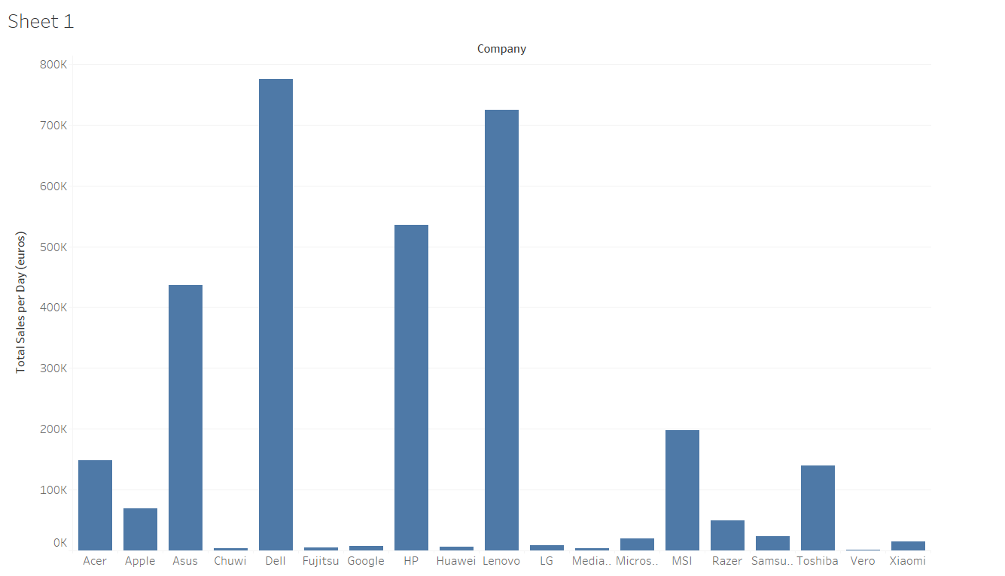

**Worksheet 2: presents the price of the product  
according to cpu and memory**

* This sheet displays a **horizontal bar** that shows the percentage of price of product based on cpu and memory.
* By using this, we can determine the price of product based on cpu and memory.
* Since we are attempting to analyse data from all across the world, a horizontal bar is the most appropriate visual to convey this.

**Analysis: In this we can see that intel core i7 7700HQ 2.8 GHz with 256 SSD + 1 TB hard disk has highest price 86,841 euros.**

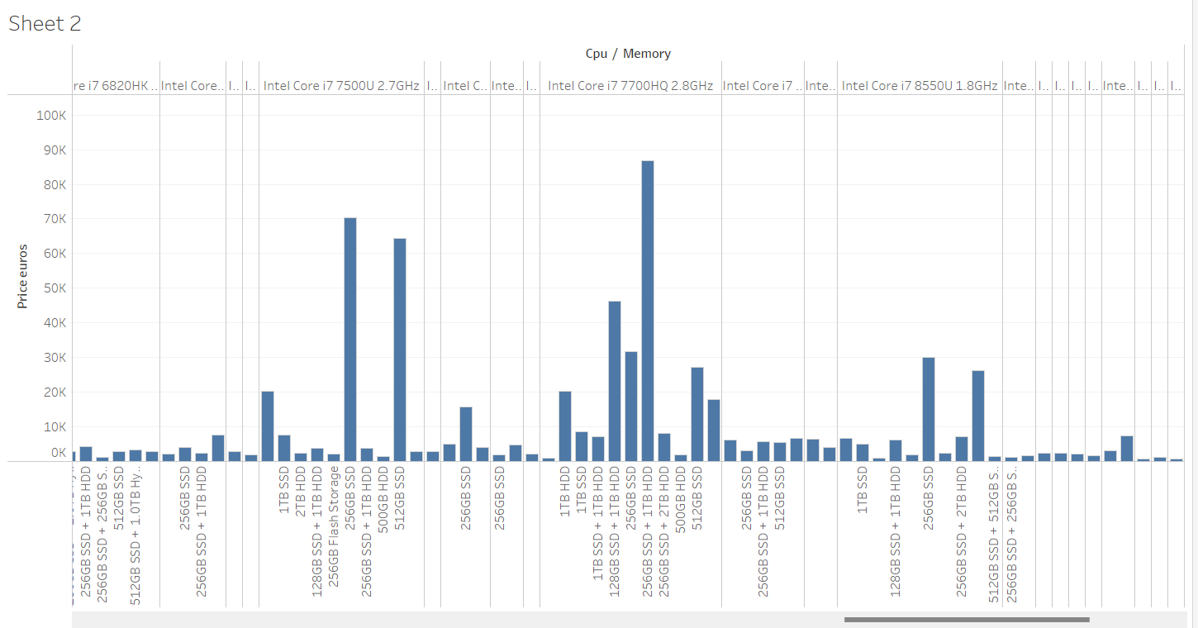

**WorkSheet 3: presents company has count of   
laptop price and sales**

* This sheet displays a bar chart that shows the company which has count of laptops price and sales.
* By using this, we can determine which company has more count of laptop price and sales
* Since we are attempting to analyse data of many company, a bar chart is the good visual to convey this because progress of bar chart give us result.

**Analysis: DELL and LENOVO has more count of laptops prices and sales which is 297 both.**

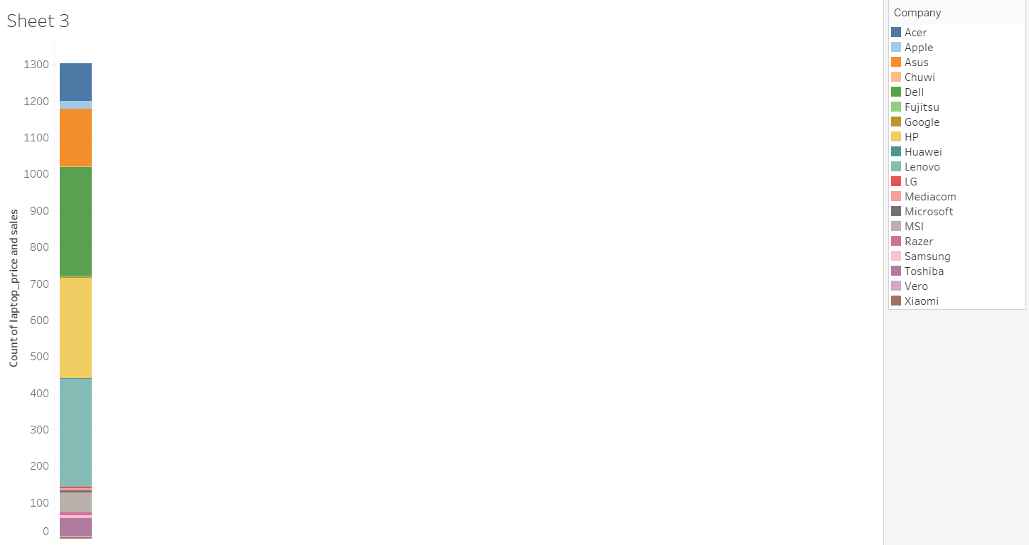

**Worksheet 4: presents which operating system is popular**

* This sheet displays a **bar chart** that shows the percentage of operating system according to sales.
* This makes it possible to determine which is used in most of the laptops.
* Since we are attempting to analyse data of many operating system , a bar chart is the good visual to convey this because progress of bar chart give us result.

**Analysis: In this we can see that laptops which has window 10 has more sales**

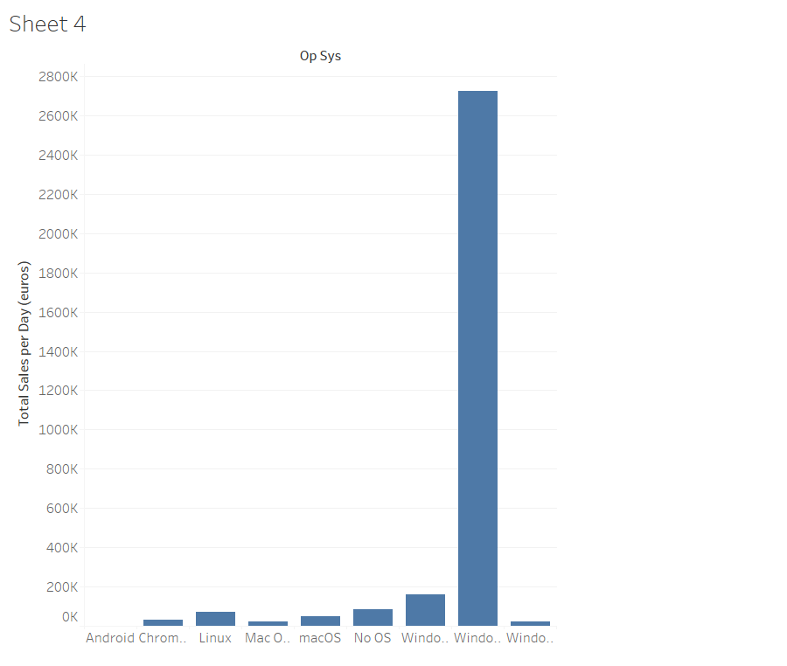

DASHBOARD :-

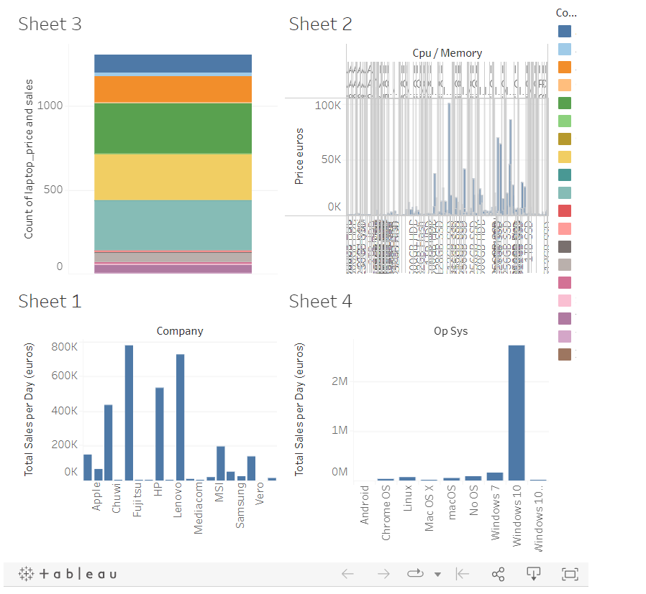

Link for Tableau dashboard is:

[Data Analysis of Different Services](https://public.tableau.com/views/salesperday/Dashboard1?:language=en-US&publish=yes&:display_count=n&:origin=viz_share_link)

**CONCLUSION**

Being part of a very successful company, like Starsun Technology Private Limited gave me a different perspective on the role of information in the workforce. The experience that I have gained from working as a data analyst was very educational. In addition, working for the company showed me the variety of tasks that I could handle as a sales informatician. Being able to utilize many of my technical skills, such as web development and SQL, combined with the statistical knowledge to handle the tasks assigned to me, proved to me that my sales informatics skills and knowledge could be applied in the workforce. The most rewarding part of working at Starsun Technology Private Limited. was the satisfaction of knowing that all the work that I did went towards helping students.